1. 

Using this information, prepare an Income Statement for 2007 and a Balance Sheet for 2006 and 2007. Using that figure out the Cash Flow from Assets, Cash flow to creditors and Cash flow to stockholders. Show that the Cash Flow identity holds.

1. 
2. 
3. 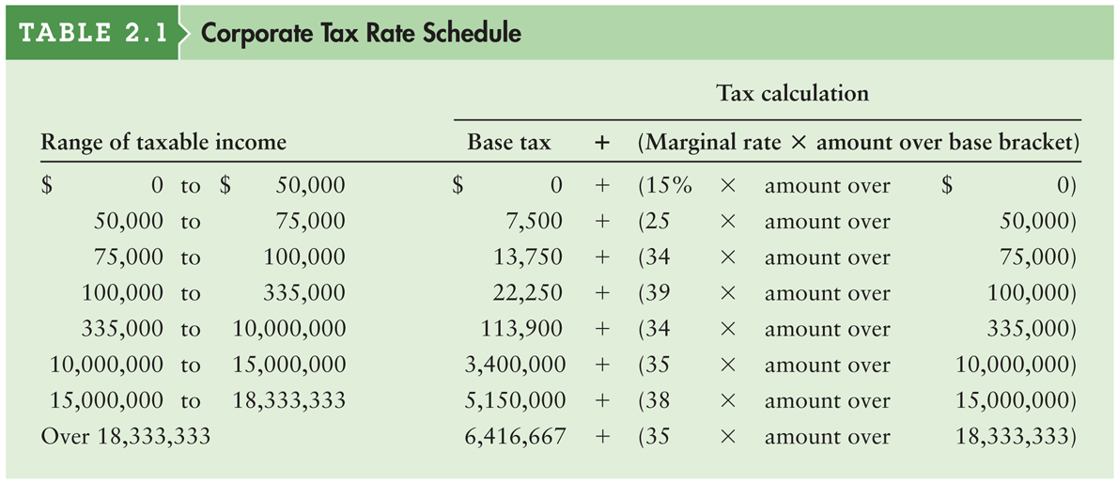
4. What is the tax bill for both the firms?
5. What is the average tax rate for both the firms? Is there any difference between the average tax rate and marginal tax rate for the firms?