Part 3
$$WACC=\left(\frac{E}{E+D}\right)R_{e}+\left(\frac{D}{E+D}\right)R_{d}(1-T)$$
R_{e}= $r_{i}=r_{RF}+\left(r_{M}-r_{RF}\right)β_{i}$
R_{rf}= Risk free rate of return. Find out this rate from Bangladesh Bank Website, search for 90 days matured Sanchyai Potro.
R_{d}= Interest Expense/Debt [Since there is no BONDS in Bangladesh, You CANNOT calculate YTM!]
For the Beta (β) Calculation, watch this Youtube tutorial:
https://www.youtube.com/watch?v=7LiK-qbmPsw [Here, GM is the company for which Beta (β) has been calculated, and S&P is the market]
Remember: You need to calculate single WACC! The r_{d} and capital structure weights should be calculated based on data from the most recent year’s financial statement that you have used in your Phase I
For your project, you need to calculate two (2) betas (β) for the two companies you have considered in part# 1 & part# 2. Since your company is traded in DSE, the DSE index will be used as market.
Part 4
The value of Common stock with free cash flow valuation method,
Value of the Company, V_{c}= PV of Cashflows from assets of 2019 + PV of Cashflows from assets of 2020 + PV of Cashflows from assets of 2021 + PV of future cashflows from 2022 till infinity.
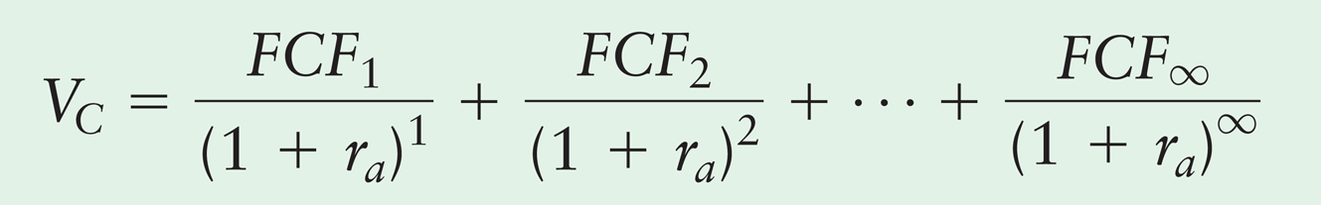

[Here, FCF₁= Cashflows from Assets of 2019, FCF₂= CFFA of 2020, FCF₃= CFFA of 2021, r_{a}= WACC]
First, discount the three cashflows that you calculated for the two firms in Proforma statements, then to find out PV of Future cashflows from 2021 till infinity, use gordon Model.
PV of Cashflows from 2022 till infinity= $\frac{\frac{CFFA2021 (1+g)}{WACC-g}}{\left(1+WACC\right)3}$ [Here, g= Average Grwoth rate of CFFA from 2014 till 2018]
Lastly, Add the PV of CFFA2019, PV of CFFA2020, PV of CFFA2021 and PV of Cashflows from 2022 till infinity. This will give you value of the company at the end of 2018, V_{c}.
Now, find out Value of Equity, V_{E}= V_{c} - V_{D} [V_{D} is the Value of Debt from 2018 Balance Sheet]
Finally, Price of Share= $\frac{Value of Equity (Ve)}{\# of shares Outstanding}$ [Use # of share outstanding of 2018]
N.B: Still Confused? Write me mail or meet me at office!

